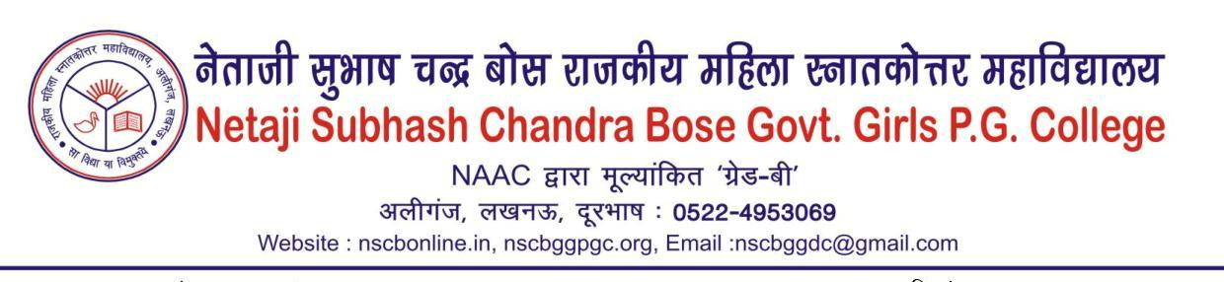
(Use of LED bulbs/ power efficient equipment)
Year 2022-23
The College seriously tries to save the electricity and power consumption by replacing normal bulbs to LED bulbs and power efficient equipments such as photocopy machines. The college is in effort to install a solar panel to generate their own energy.
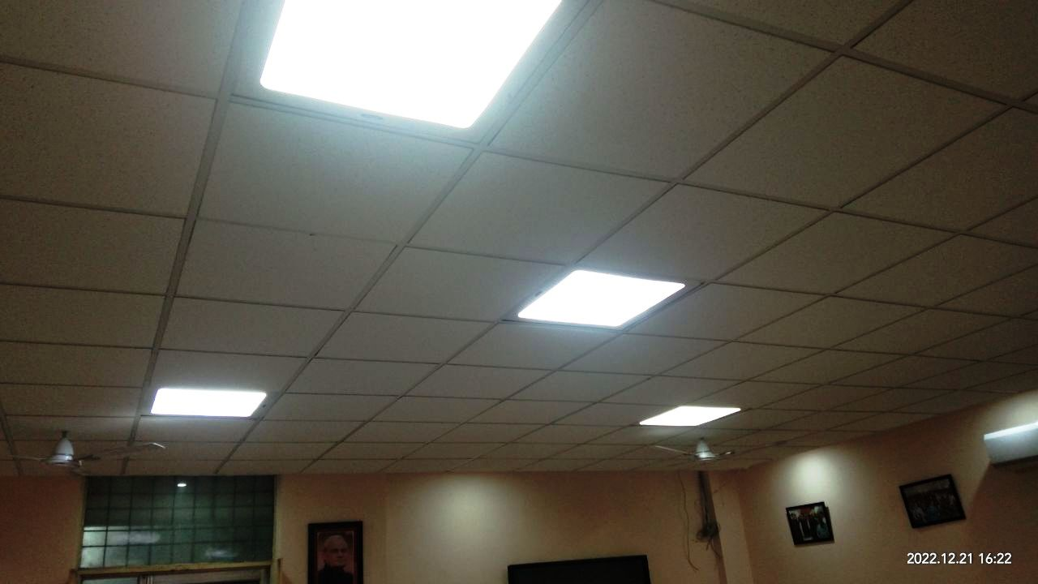

ATAL KAKSHA with LED LIGHTS

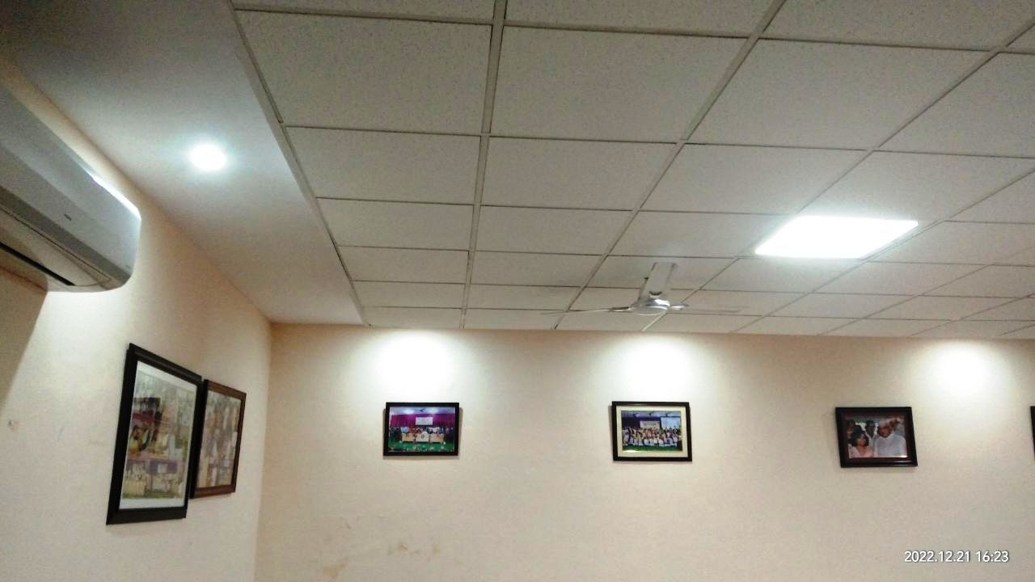
ATAL KAKSHA with LED LIGHTS

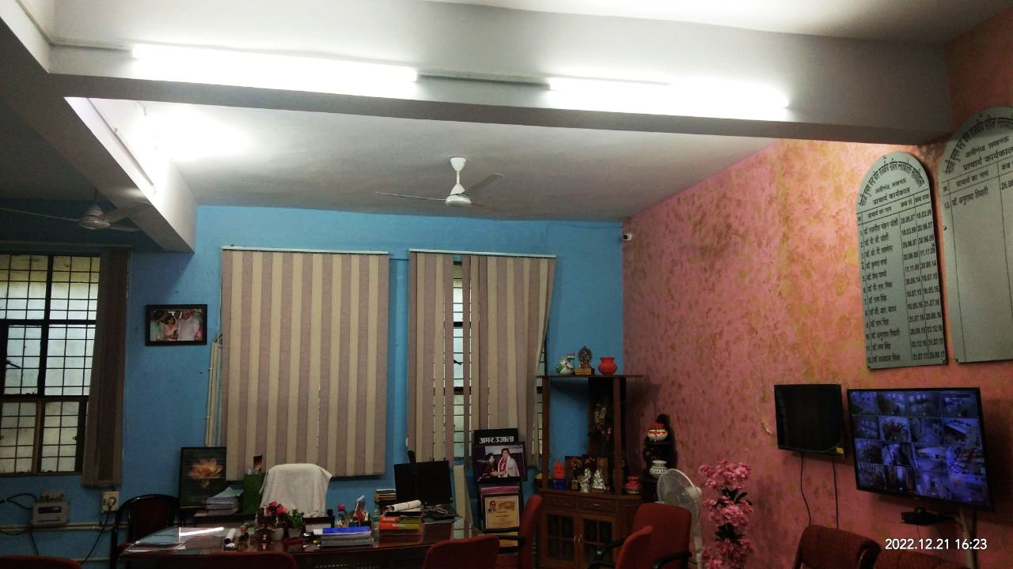
Principal Room with LED TUBELIGHTS
Principal Room with LED TUBELIGHTS

